**DAILY ONLINE ACTIVITIES SUMMARY**

|  |  |  |  |  |  |  |  |  |
| --- | --- | --- | --- | --- | --- | --- | --- | --- |
| **Date:** | **30/05/2020** | | | | | **Name:** | **Harshitha M** | |
| **Sem & Sec** | **8th 'A'** | | | | | **USN:** | **4AL16CS038** | |
| **Online Test Summary** | | | | | | | | |
| **Subject** | | **-** | | | | | | |
| **Max. Marks** | | **-** | | **Score** | | | **-** | |
| **Certification Course Summary** | | | | | | | | |
| **Course** | **Python for machine learning** | | | | | | | |
| **Certificate Provider** | | | **Great learning** | | **Duration** | | | **4hr** |
| **Coding Challenges** | | | | | | | | |
| **Problem Statement:**  **prob1:Find the number that is missing from the array containing distinct number taken from 0,1,2....n** | | | | | | | | |
| **Status: Solved**  **Solution link: https://github.com/alvas-education-foundation/Shwetha-** | | | | | | | | |
| **Uploaded the report in Github** | | | | | **Yes** | | | |
| **If yes Repository name** | | | | | **Harshitha-M** | | | |
| **Uploaded the report in slack** | | | | | **Yes** | | | |

Certification Course Details:

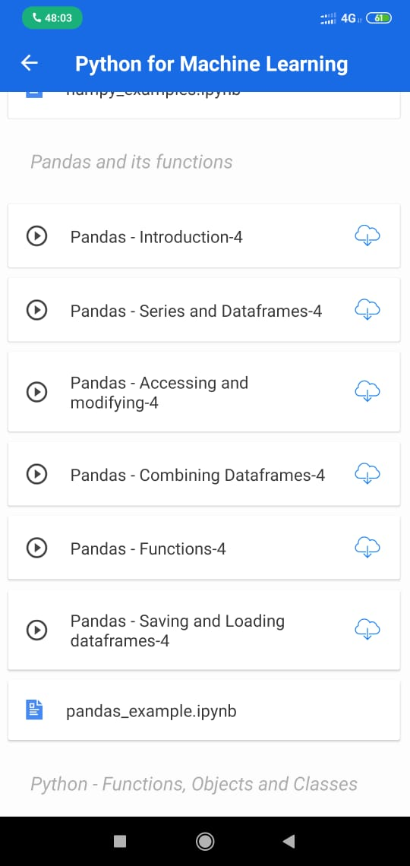

Coding Challenges Details:

#include<stdio.h>

intgetMissingNo(inta[],intn)

{

inti,total;

total=(n+1)*(n+2)/2;

for(i=0;i<n;i++)

total-=a[i];

returntotal;

}

intmain()

{

inta[]={1,2,4,5,6};

intmiss=getMissingNo(a,5);

printf("%d",miss);

getchar();

}